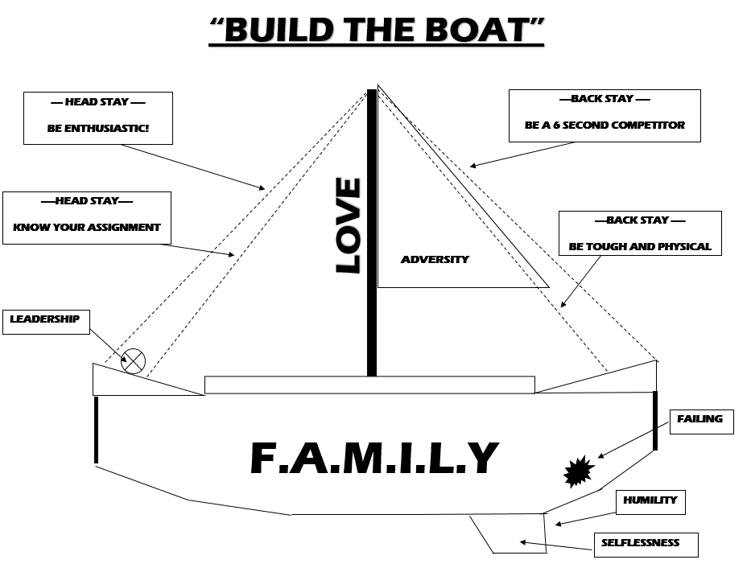
“BUILD THE BOAT”
ATTENTION – “EYES ON YOU”
THE BOAT
- KEEL – KEEPS THE BOAT UPRIGHT. YOU CAN’T SEE IT BUT IS THE MOST IMPORTANT PART OF THE BOAT
  - WE SAY THE KEEL = SELFLESSNESS: TEAM/ME
    - HUMILITY: A MODEST OR LOW VIEW OF ONES OWN SELF
- HULL – BIGGEST PART OF THE SHIP. HOLDS EVERYTING TOGETHER
  - WE SAY THE HULL = F.A.M.I.L.Y. (FORGET ABOUT ME, I LOVE YOU)
- MAST – SACRIFICES TO HOLD UP THE SAIL
  - WE SAY THE MAST = LOVE: LOVE IS A SACRIFICE
- SAIL – TAKES THE WIND AND TURNS IT INTO ENERGY
  - WE SAY THE SAIL = ADVERSITY (WHEN ADVERSITY HITS; PARK IT, REFOCUS, & DELIVER YOUR BEST)
- HEAD STAYS – SUPPORTS THE SAIL FROM THE FRONT
  - WE SAY THE HEAD STAYS = BE ENTHUSIASTIC & KNOW YOUR ASSIGNMENT
- BACK STAYS – SUPPORTS THE SAIL FROM THE BACK
  - WE SAY THE HEAD STAYS = BE A 6 SECOND COMPETITOR
                - PLAY TOUGH & PHYSICAL
- STEERING WHEEL – STEERS THE BOAT
  - WE SAY THE STEERING WHEEL = LEADERSHIP: THE ABILITY TO MAKE THOSE AROUND YOU BETTER
                - ANYONE CAN LEAD
- HOLES IN THE BOAT – REPRESENTS THE STRUGGLE
  - WE SAY THE HOLES IN THE BOAT = FAILING: A POSITIVE RESPOPNCE TO GROWTH

